A concurrent algorithm, resient approach to share data during an earthquake
Tarun Keswani, Sankalp Jadon, Hari Charan Panjwani, Sameer Goel, Cuican Wang
Information Systems Department, Civil&Environmental Engineering Department, College of Engineering, Northeastern University
Boston, MA, USA

Abstract—during a disaster, countless number of lives are at stake. The problem lies in ineffective communication between the government authorities, volunteers, NGOs and public etc. Because a strong earthquake or hurricane can severely damage the communication infrastructure. Once the regular communication lines are down, it’s very difficult to get an overview of the disaster and get the accurate statistics pertaining to the loss at the site, and requirements like relief material. This is primarily due to ineffective and fragile communication channel between concerned authorities and volunteers. The data gathered is inaccurate due to data duplication from various different sources, which in our case are the volunteers.
To solve this problem, we have a conceptual device model, which is an enhanced version of ham radio operating on radio frequency that can send text messages. The device works on broadcast mode and the minimum effective radius of the device is 30km. With a large effective range, volunteers can be closely connected. The device works on Wireless Mesh Network (WMN), enabling users to be connected and share data. A heuristic algorithm is used to reduce traffic congestion. A concurrent addition algorithm designed by us is the main principle of the model.
Keywords-component;disaster; communication; ham radio; mesh network;

Introduction
There is a great need for smooth communication during an earthquake rescue. At that time, almost all the communication by public network disrupted due to the suddenness and unpredictability of the earthquake. After the earthquake, there will be so many calls from everywhere to the earthquake location. This will result in the network congestion.

In May, 12th, 2008, an 8 Richter scale earthquake shook Wenchuan, China and killed nearly 80 thousands people. In the half hour after the earthquake happened, the first call from Wenchuan to outside was made by satellite phone. But afterwards it didn’t work. According to the past experience, the survival and rescued within 24 hours can reach 90%, if a clear and transparent communication channel is in use. Therefore a reliable emergency communication device is intensely needed.

Existing models and shortcomings
Existing devices used by ground staffs during a disaster are as following: satellite phone, cell phone or ham radio. Cell phone is unreliable as the communication infrastructure is volatile during a disaster. A high intensity earthquake or a hurricane can disrupt the infrastructure required to make phone calls, disrupting the communication modes. As people try to reach their relatives by phone call, messages, resulting in network congestion.
Both satellite phones and ham radio have negligible traffic due to small message size, and less users.
A satellite phone or terminal is proved to be an effective device in such situation. It connects to a satellite to provide communication in isolated places instead of connecting to terrestrial cell sites.
However, it works only when a direct line of sight exists in the sky. It can’t be used indoors or during inclement weather or when the operator is inside a building or in a sheltered area. This scenario is highly impractical. High operating cost of a satellite phone does not make it a useable device. It requires a service payment per minute which is very high. This is not feasible for a large team of NGO volunteers.

Proposed Device description
Proposed model is based upon ham radio to pass messages through radio frequency. The existing ham radio setup allows for a two-way communication between two devices. Our device will be redesigned to be used by the volunteers present at the disaster location, on a multi-emission mode which allows multiple to multiple message sharing. The user interface will involve a set of options like:

Number of casualties?
Number of people injured?
Number of houses destroyed?

The device will use the range of ham frequency. On approval of government, the use of other distress frequencies can also be permitted. Such channels are known as distress, safety and calling frequencies, typically ranging from 30 MHz to 500MHz.
A clear operational instructions for response in emergency is a required attribute of any device. In a study by the Rehabilitation Engineering Research Center for Wireless Technologies, it was revealed that regardless of the initial form of notification, a secondary form was necessary before action would be taken. This supports the important observation that providing clear and concise instructions may reduce dependency on such secondary verification; and thus, providing instructions may save lives in an urgent emergency situation. Keeping this in mind, a simple user interface is required on the device.

Wireless Mesh Network
WMN nodes are comprised of mesh router and clients. The nodes operate not only as a host but also as a router, forwarding packets on behalf of other nodes that may not only be within direct wireless transmission range of their destinations. Wireless mesh network (WMN) consists of mesh routers and mesh clients where mesh routers have minimal mobility and form the backbone of the WMN. It provides network accesses for the both mesh and conventional client’s. The Mesh clients can be either stationary or mobile and can form a client mesh network among themselves with mesh routers.
The router forwards the message that reaches all the nodes over the wireless mesh network. The packets are forward through the router nodes only. All the nodes apart from the router nodes are client nodes. Optimizing flooding is done by minimizing the number of router nodes in the mesh network in such a way that any client node can be reached through the least number of hops that passes through the least number of routers.
The router node can relay and retransmit the packets and the client node exchanges packets through the router nodes. We consider the packet exchange done by sharing of a common channel. Let 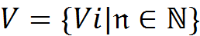 the set of all types of nodes in the wireless mesh network [1]. Now 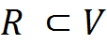 be the sets of all routers in the wireless mesh network. In the proposed problem we consider that in the wireless mesh network, any 2 hops neighbor must be covered by at least one node R_{j} ϵ R .Any node R_{j} ϵ R forwards a flooding packet with the condition that the packet has not already been received and that node is the last emitter .To minimize the number of packets in the wireless domain and send the packet through lest hops the below cardinality condition holds true, 1) The cardinality of the set (R) < cardinality of set (V) 2) Cardinality of set R < cardinality (V-R). Now, let S be the source node to initiate a massage, that message can reach every client node through the minimum number of hops. Figure 1 is Architecture of the Distributed Nodes. The source {S} contains the nodes {R₁, R₂, R₃}. These are router nodes from set R to relay the message. When a flood message comes from source node S only for {R₁, R₂, R₃}, then the message can be retransmitted from the nodes {R₁, R₂, R₃}. Any two hops neighbor must be covered by at least one node from set R. The router forwards a flooding message with following rules:
The packet has not already been received.
The router node is the last emitter.
The message re-transmits follows this way. If node A receives message from R2 for the first time then it will retransmit, if node A receives from R1 for the first time it won’t re-transmit that packet. No client node will be missed to receive the message. Any node C (say) neighbor of the node A is a 2 hop neighbor of R1. So any variable node which is at outer of the 2nd circle be covered by the 2 hops of any node R_{j} ϵ R. We locally optimize the number of flooding packet. After that we proceed to optimize the flooding special packet by heuristic algorithm to cover the whole mesh network by transmitting minimum number of flooding packet. This is done to efficiently utilize the bandwidth of wireless network and remarkably reduce the contention in the wireless domain. In this procedure we can reduce the race condition to occupy the sharable channel in the wireless domain. This procedure reduces traffic loads in wireless domain. In wireless medium, random packets loss is a common issue due to random movement of nodes in wireless domain. The main disadvantage of the common proactive routing algorithm is the slow reaction on restructuring of topology. The other is a respective amount of data used for maintenance.

Transferring data in such a large scale will increase the chances of congestion even if an isolated radio frequency is used. An enhanced form of WMN, using heuristic algorithm to reduce traffic load can be incorporated to support large scale data transmission and sharing. The utilizing of mesh networks could reduce the dependence in the communication system and strengthen robustness of the system significantly.

Here is a demo of heuristic algorithm in the wireless mesh domain [1].
The main characteristic of routing algorithm is decentralized, self- organizing and self-healing.
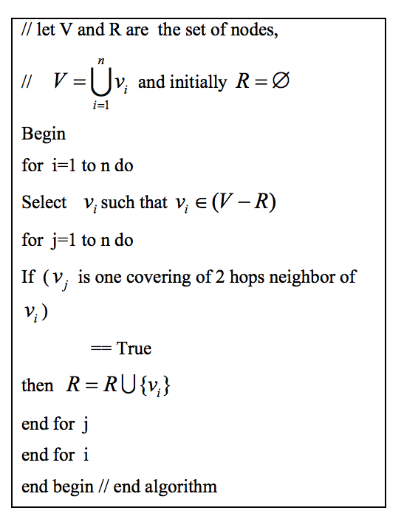
- Demo of heuristic algorithm in the wireless mesh domain.

The proposed concurrent addition algorithm
Using our proposed concurrent addition algorithm, every numeric response against the question answered by the volunteer will be broadcasted to the nodes in the range, and will show on every volunteers screen. The message will hop to other nodes in range. Every message will have a unique ID, which can comprise of a device ID, Message ID(The question ID to which the answer is sent), Session ID(The count of message sent by that particular device). Using a combination of these unique IDs, one single message ID will be formed.
If a node transmits the same message back to the previous node, the filter will look for the ID, and reject if found duplicate.

In Fig. 2,
D- Device (Nodes)
M- Message ID
S- Session ID
T- Total of all the messages in the network.

The first picture in fig2 shows that the device D1 sends a message on the network to D2, D3, and D4 with ID: D1.M1.S1=100(No. of casualties=100). The message will be received by all the devices in range (D2, D3 and D4). Same message will be saved in the total variable of the sender. Since D5 is out of range, but in reach of D4, D4 will forward this message to D5 with the same ID. Every device will save this number in the variable T (which means total), including device D1. After one cycle of messages, every device will display 100 as the no. of casualties.

The second picture shows that device D4 sends a text message on the network to D1, D2, D3 and D5 with the ID: D2.M1.S2 =150 (No. of people dead=150). The message will be received by all the devices in range (D1, D2, D3 and D5). Every device will update this number in the variable T, including device D4. So now variable T= 100+150= 250. There will also be a destination node in the network which is responsible to get the variable T and broadcast it to public. So now, the total number of casualties on each device= 250

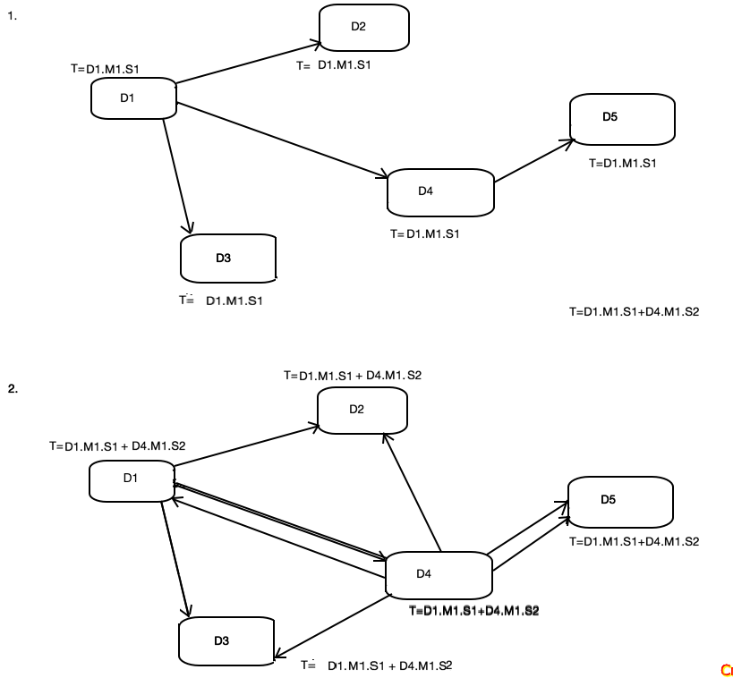
- Example of a message sharing.

CONCLUSION
The problem of an effective communication mechanism during the disaster can be resolved using ham radio and Wireless Mesh Network. By using concurrent addition algorithm, real time concurrent data can be gathered, reflecting in every connected device in mesh network. The data will be shared on the public radio station, from where it will be distributed to the government, enabling the planning and management of the rescue work more efficiently.

References

[1] Zhikui Chen, Liao Chen, Yang Liu, Yong Piao, “Application Research of Wireless Mesh Network on Earthquake”- 2009
International Conference on Industrial and Information Systems.
[2] https://en.wikipedia.org/wiki/Emergency_communication_system.
[3] http://www.globalmarinenet.com/hf-radiovs-satellite-phones-what-is-really-free
[4] Soumen Kanrar, “Efficient Packet Forwarding in Mesh Network”- ijim.v6i2.1991

